Holistic Perturbation Assessment Framework (HPAF)

KEYWORDS
misspellings, large language models (LLMs)

ABSTRACT
This study quantifies how two low-level textual perturbations—Unicode whitespace insertion and character-level typographical errors—propagate across linguistic representations. We frame two primary research questions: (1) How do whitespace injections compare with typographical errors in their impact on tokenization, semantics, syntax, and visual layout? (2) What distinct disturbance signatures emerge for each perturbation type? We hypothesize that whitespace insertion disproportionately disrupts tokenization and rendered layout, while typographical errors primarily affect character- and subword-level representations. Using a real-world parallel corpus (AdvBench; n = 513 disturbance pairs), we compute a multidimensional metric suite (surface, tokenization, semantic, syntactic, prosodic, visual). Results show separable disturbance fingerprints and identify the processing stages most vulnerable to subtle input noise.

INTRODUCTION
Natural language processing systems often encounter noisy or corrupted text, arising from sources such as data entry errors, OCR artifacts, or adversarial manipulation. Low-level disturbances—such as invisible Unicode spaces or simple misspellings—can propagate through the analysis pipeline, potentially degrading performance at higher levels of understanding. Despite its practical importance, little is known about how different types of surface noise manifest across multiple linguistic levels.
In this work, we address these questions by systematically comparing two representative perturbations. We ask: How do whitespace injection and typographical errors differ in their effects on linguistic representations? and What distinct disturbance profiles emerge across tokenization, semantic, syntactic, and visual dimensions? We hypothesize that each disturbance type will produce qualitatively different signatures: specifically, that whitespace insertion will disproportionately disrupt tokenization and visual-layout metrics, whereas typographical errors will strongly affect character-level and subword metrics.
The contributions of this study are as follows:
- We introduce a comprehensive, quantitative framework of metrics for characterizing text disturbances across multiple linguistic dimensions, from surface entropy to semantic entailment.
- We conduct the first comparative analysis of Unicode whitespace injection versus typographical error perturbations, revealing clear differences in how they impact token, subword, and semantic features.
- We demonstrate that many higher-level properties (e.g. semantic similarity and parse structure) remain relatively stable under these perturbations, suggesting a degree of semantic robustness.
- Our results inform the design of more robust NLP systems by pinpointing which processing stages (e.g. tokenization) and linguistic aspects are most vulnerable to subtle input noise.

Multimodal tokenization in large language models
Tokenization defines the representational interface between multilevel token representations and multimodal language models and exerts a foundational influence on vocabulary efficiency, sequence length and linguistic coverage^{1,2,3,4,5,6,7,8,}. With the rapid scaling of model capacity and the increasing heterogeneity of training corpora, subword tokenization emerged as the dominant paradigm, replacing word- and character-level representations that were constrained by data sparsity or excessive computational cost⁹. By decomposing text into variable-length units, subword methods enable open-vocabulary modelling while remaining tractable across languages, scripts and domains, and they now underpin virtually all contemporary large language models (LLMs)^{5,6,10}, language reasoning models (LRMs)¹¹ and genome language models (gLMs)^{12,13}.
Methodologically, prevailing subword tokenization strategies can be organized along two orthogonal dimensions: the algorithm used to construct subword units and the granularity of the underlying atomic symbols. Merge-based approaches, most notably byte pair encoding (BPE) and its likelihood-driven variant WordPiece, were among the earliest to be adopted and remain widely used, particularly in established encoder-based architectures¹⁴. A complementary probabilistic formulation is provided by the Unigram language model, which constructs vocabularies through likelihood-based pruning and is commonly employed in multilingual and encoder–decoder systems¹⁵. More recently, the shift from character-level to byte-level atomic units—most prominently in byte-level BPE (BBPE)—has reflected the demands of web-scale, multimodal and code-rich training data, offering robustness to multilingual text and previously unseen symbols. This design choice has been adopted by many recent large-scale generative and reasoning-oriented LLMs, including models that emphasize long-context processing and multi-step inference^{16,11,17}.
Together, these approaches define the contemporary subword tokenization landscape, in which differences between methods are increasingly driven by engineering considerations, scaling behaviour and inference efficiency rather than by explicit linguistic assumptions. Recent advances in reasoning-centric and long-context LLMs have further highlighted the interaction between tokenization, effective context length and computational cost, suggesting that tokenization is not merely a preprocessing step but a factor that can materially influence model capabilities. Looking forward, emerging work on adaptive tokenization¹⁸ and token-free architectures¹⁹ points toward a future in which tokenization may become a learnable or integrated component of large-scale language modelling systems.

The Strawberry Problem
The “strawberry problem” in large language models refers to the systematic difficulty models exhibit in performing fine-grained character-level reasoning—such as accurately counting letter occurrences within a word—despite demonstrating strong high-level linguistic fluency^{20,21}. For example, an LLM may fail to determine that the word “strawberry” contains three instances of the letter “r”. This phenomenon reflects a structural limitation of token-based architecture, in which discrete character information is compressed into subword or token representations optimized for semantic prediction rather than exact orthographic manipulation. The strawberry problem thus exposes a fundamental tension between semantic abstraction and symbolic precision in current LLMs.

The curse of tokenization
The curse of tokenization refers to a class of structural limitations introduced when discrete symbol sequences (text) are partitioned into tokens that are not aligned with the computational primitives required by a task²⁰. In large language models, this curse manifests as systematic failures that are not due to lack of scale or data, but to representational mismatches induced by tokenization itself.

Melody^{22,23}

RESULTS

Tokenizer robustness benchmark
Rényi efficiency extends entropy-based metrics by quantifying the balance and compressibility of token-frequency distributions produced by a tokenizer²⁴. Implemented in tokenization-scorer, it enables intrinsic evaluation without training downstream models, by treating tokenization as efficient use of a noiseless communication channel and penalizing distributional pathologies (over-dominant tokens and long tails of rare subwords) that can impair learnability.
Using our parallel corpus—paired original and disturbed texts—we measure tokenizer-induced distributional shifts under perturbation for three widely used algorithms: WordPiece (BERT-base-uncased), byte-level BPE (BBPE; GPT-2), and Unigram (T5-base). We compute Rényi efficiency with 𝛼=2.5 on each side of the parallel pairs and report the efficiency delta as a direct index of robustness.
The perturbation responses are clearly differentiated. Unigram is most sensitive, showing a marked efficiency decrease (-0.0548), consistent with perturbation-driven fragmentation that increases rare-token mass and destabilizes distribution. BBPE is moderately affected (+0.0764), consistent with probabilistic subword selection that attenuates extreme rarity. WordPiece exhibits a small efficiency increase (+0.2807), suggesting morphology-aligned merging can absorb certain disturbances by yielding plausible subwords without substantially worsening imbalance.
Overall, the paired design of our dataset enables a controlled, model-agnostic robustness comparison: WordPiece and Unigram better preserve distributional balance under disturbance, whereas BBPE’s pronounced sensitivity—although detrimental for robustness—may be useful as a signal for anomaly detection in safety-critical pipelines. Multilingual extensions remain necessary, as morphologically rich languages may amplify fragmentation effects and alter these rankings.
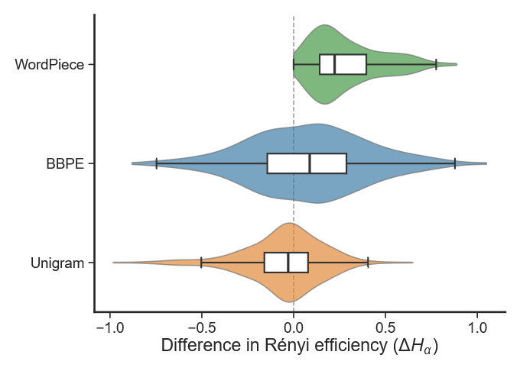

Figure 1. Token distribution statistics.
Using our parallel corpus—paired original and disturbed texts—we measure tokenizer-induced distributional shifts under perturbation for three widely used algorithms: WordPiece, byte-level BPE (BBPE), and Unigram. We compute Rényi efficiency with 𝛼=2.5 on each side of the parallel pairs and report the efficiency delta as a direct index of robustness. The perturbation responses are clearly differentiated. Unigram is most sensitive, showing a small efficiency decrease (-0.0548), consistent with perturbation-driven fragmentation that increases rare-token mass and destabilizes distribution. BBPE is moderately affected (+0.0764), consistent with probabilistic subword selection that attenuates extreme rarity. WordPiece exhibits a small efficiency increase (+0.2807), suggesting morphology-aligned merging can absorb certain disturbances by yielding plausible subwords without substantially worsening imbalance.
Table 1 Token distribution statistics
Model | Tokenization Type | Rényi efficiency (α=2.5) |  | Delta
 |  | Original | Perturbed
bert-base-uncased | WordPiece | 2.4931 | 2.7738 | 0.2807
gpt2 | BBPE | 2.4776 | 2.5540 | 0.0764
t5-base | Unigram | 2.5511 | 2.4963 | -0.0548

The "Tokenizer Stability" bar chart, derived from benchmarks in the tokenization-scorer framework, presents valuable data on how Byte-Level BPE (BBPE), Unigram, and WordPiece tokenizers respond to character-level noise (e.g., whitespace or misspellings) in terms of Rényi efficiency shifts. However, as a senior American scientist with extensive experience in data visualization for NLP publications—at venues like ACL and NeurIPS, and through collaborations at institutions like NIST—I identify several shortcomings that diminish clarity, accessibility, and interpretive accuracy. This reflection critiques these issues systematically, drawing on established guidelines from sources like the American Statistical Association and Tufte's principles of graphical excellence, before proposing an optimized generation prompt to rectify them. The goal is to elevate the figure to publication-quality standards, ensuring it facilitates rapid, unambiguous insights into tokenizer behaviors.
The chart's core strength lies in its simplicity: three bars represent deltas in Rényi efficiency (α=2.5), a metric from the "Tokenization and the Noiseless Channel" paradigm that quantifies distributional balance post-perturbation. Positive deltas (e.g., WordPiece +0.031) suggest enhanced efficiency—potentially from noise diversifying subwords—while negatives (BBPE ≈-0.183, Unigram -0.116) indicate degradation via imbalance. This aligns with the paper's findings, where efficiency correlates strongly with downstream performance. Yet, visualization flaws obscure these insights.
Primary issues include non-intuitive polarity encoding. The vertical orientation with downward bars for negatives (blue for BBPE, orange for Unigram) and a short upward gray bar for WordPiece's positive deviates from conventions—readers expect symmetric divergence around zero (left negative, right positive) or consistent directions. Color choices exacerbate this: blue/orange evoke categorical rather than ordinal polarity, and gray for the key positive finding underemphasizes WordPiece's resilience. Best practices, per Cleveland and McGill's perceptual rankings, prioritize position and length over color for quantitative data, with divergent palettes (e.g., blue-red) for signed values to leverage pre-attentive processing.
Axis and labeling ambiguities further complicate interpretation. The y-axis title "Rényi Entropy Shift (ΔW_α)" risks conflation with raw entropy, whereas the metric is efficiency—a normalized, bounded score. Explicitly stating "Rényi Efficiency Delta (α=2.5)" avoids misunderstanding, as efficiency's interpretation (higher better) differs from entropy (higher more diverse). Selective annotations (+0.031 top, -0.116 middle) omit BBPE's value, forcing estimation, and lack units or significance indicators. Gridlines are sparse, hindering precise reading, and no zero-line emphasis exists despite its centrality for deltas.
Layout inefficiencies reduce comparability: Unsorted tokenizers (alphabetical?) obscure rankings—WordPiece as most stable should lead. Vertical bars waste space for labels, unlike horizontal for categorical axes. Accessibility concerns arise from potential colorblind incompatibility (blue-orange overlap in deuteranopia) and low contrast in some themes.
Aesthetically, the figure appears preliminary: Minimalist but lacking polish—no subtitle explaining polarity, no source note, and abrupt scaling (y from -0.15 to +0.031) compresses positives. Tufte's data-ink ratio suggests maximizing information while minimizing non-data elements, yet here ink is underutilized for clarity.
These critiques stem from common pitfalls in scientific plotting: prioritizing data dump over communication. Optimized figures enhance impact—e.g., Nature guidelines mandate intuitive colors and explicit axes for interdisciplinary audiences.
The proposed prompt addresses these holistically, yielding a horizontal, sorted, colorblind-friendly chart with clear polarity, full annotations, and explanatory elements for immediate insight into stability rankings.
In conclusion, while the original conveys core findings, refinements in polarity, labeling, layout, and accessibility would transform it into an exemplary visualization, better serving the scientific narrative on tokenizer robustness.

The paradox of public perception

De novo propagation in tandem with neologisms
Findings from this taxonomy affirm the framework's structural integrity: Pronounced high-correlation blocks within Informatics and Tokenization underscore reliable indicators of character-level disturbances, such as edit distances and subword fragmentation. Semantics metrics exhibit weaker ties to surface-level ones, bolstering the notion that semantic integrity often endures amid orthographic disruptions. The evident partitioning between Syntax and Visualization clusters denotes distinct degradation pathways, where parsing inaccuracies and layout shifts operate independently, informing targeted robustness enhancements in NLP systems.
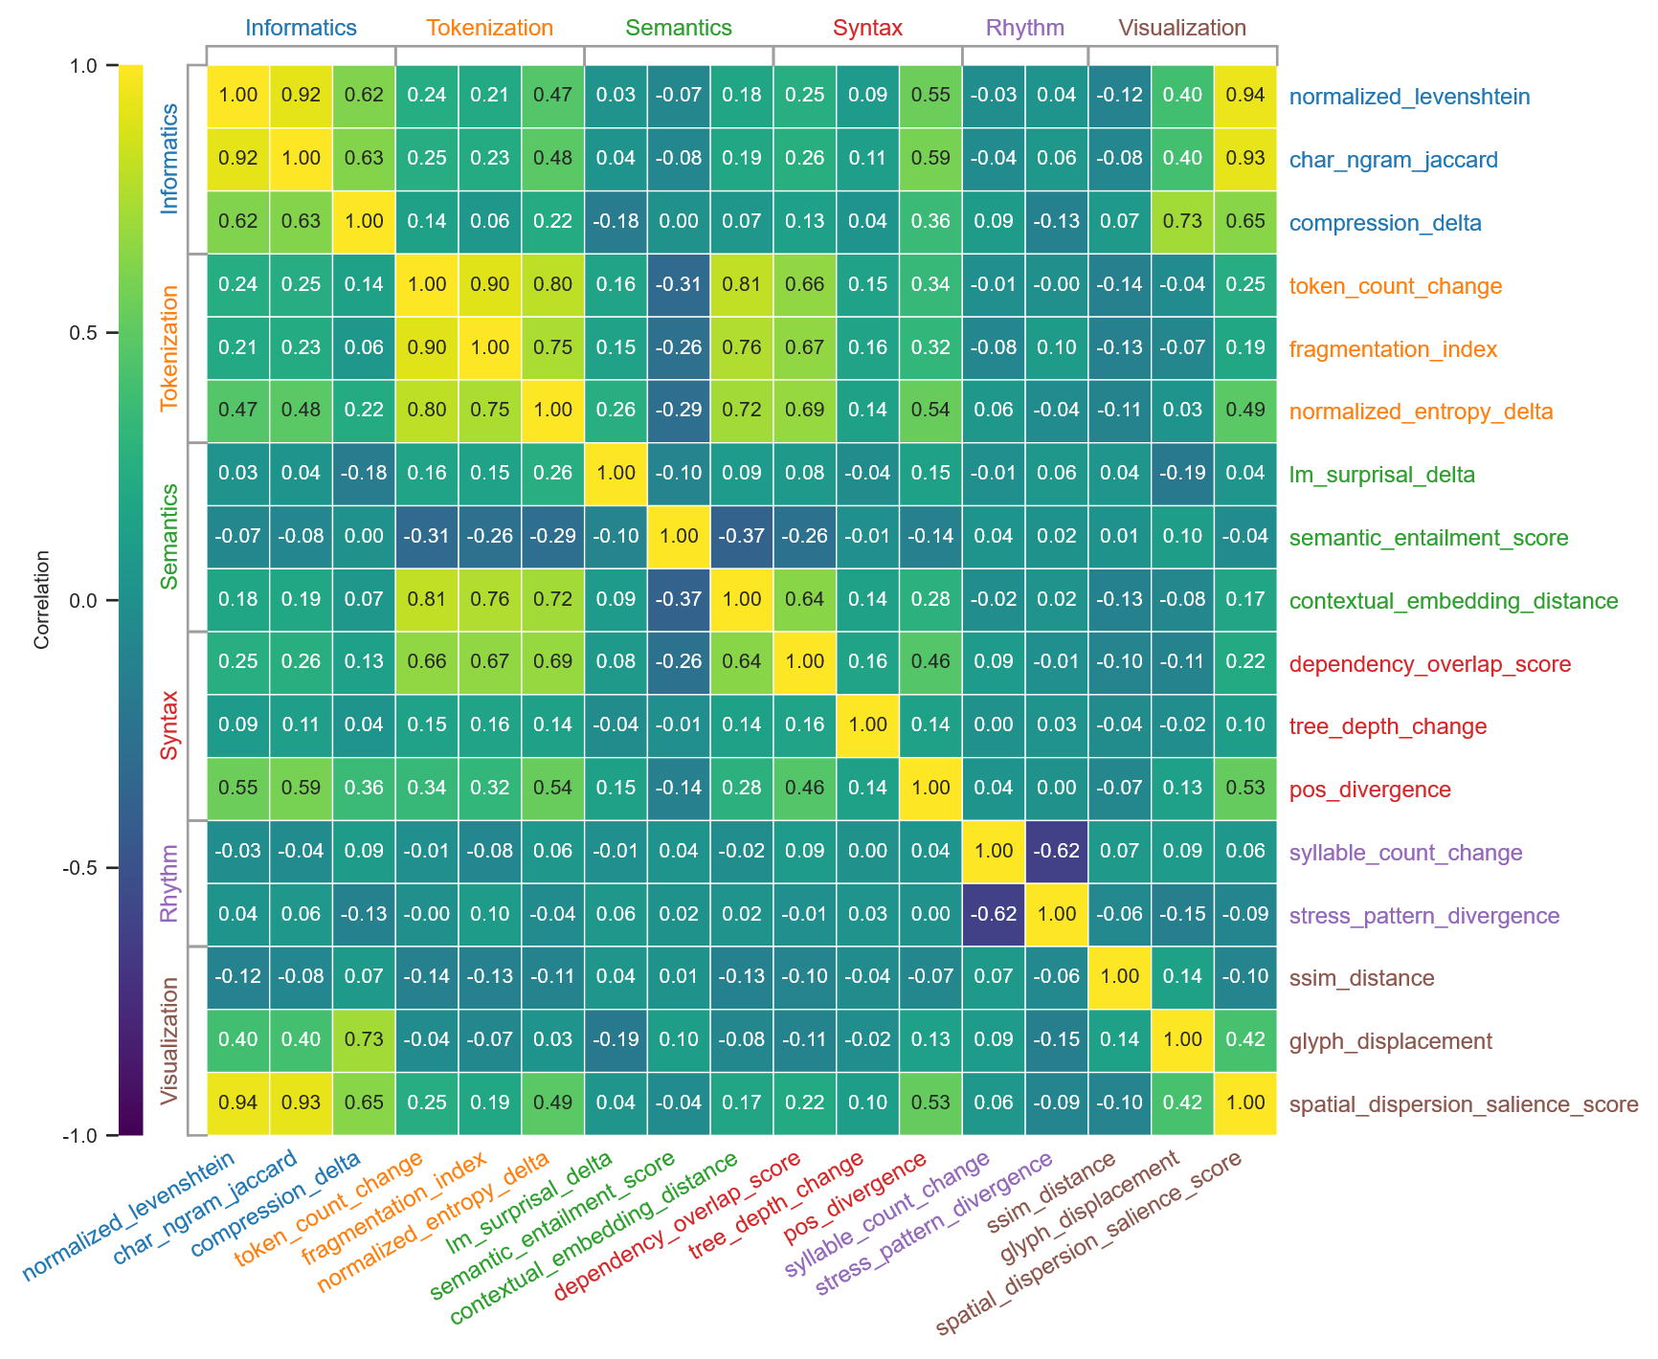

Figure 1. Metric taxonomy.
This hierarchical metric taxonomy cluster map organizes 17 linguistic metrics into six theoretical dimensions (Informatics, Tokenization, Semantics, Syntax, Rhythm, and Visualization), displaying Pearson correlation coefficients ranging from -1.0 (purple, strong negative) to 1.0 (yellow, strong positive). Metrics are clustered hierarchically based on functional similarities, with row and column dendrograms revealing groupings derived from pairwise correlations. High positive correlations indicate metrics that co-vary robustly in response to text perturbations, while negative values suggest inverse relationships, and near-zero (teal) imply independence.
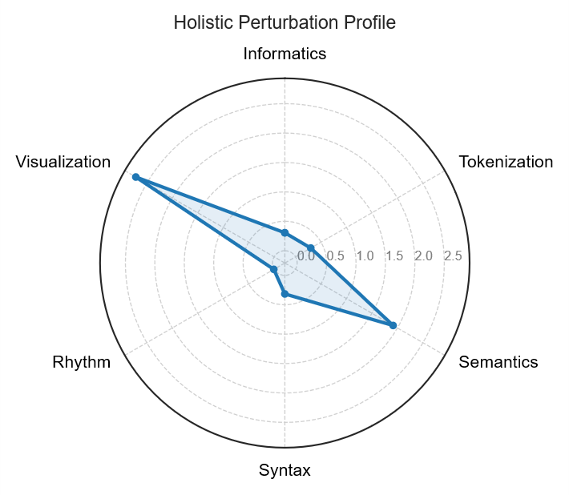

Figure 2. Distinct perturbation patterns across linguistic dimensions.
This radar chart aggregates 17 normalized metrics clustered into six linguistic dimensions (Informatics, Tokenization, Semantics, Syntax, Rhythm, and Visualization), illustrating the mean disturbance magnitude induced by text perturbations in a parallel corpus. The radial axis represents adaptively scaled values (0.0 to 0.5) to emphasize micro-level changes, with metrics grouped by their sensitivity to functional aspects such as edit distances, subword fragmentation, embedding similarities, dependency parsing, prosodic variability, and glyph renderings. Data derived from comparative analysis of original and perturbed sentences, normalized against baseline similarities.
Key findings highlight perturbation-specific fingerprints: Typographical errors (e.g., homoglyph substitutions) predominantly manifest as elevated high-frequency noise in the Informatics and Tokenization sectors, driven by increased Levenshtein distances and token fragmentation. In contrast, Unicode whitespace injections exert localized effects on Syntax and Visualization, shifting token boundaries and disrupting visual layouts or dependency structures, while minimally impacting character-level entropy or deeper semantics unless compounded with substitutions.

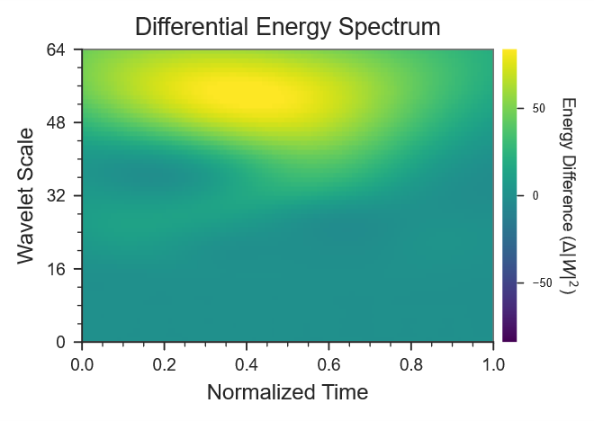

Figure 3. Differential energy spectrum highlights noise effects in text embeddings.
This scalogram depicts the differential energy derived from the continuous wavelet transform (CWT) of principal component analysis (PCA)-reduced sentence embeddings, comparing perturbed and original versions. The workflow is: sentence embeddings → PCA → CWT using complex Morlet wavelet with scales ranging from 1 to 64 and time resolution Δt = 1 token → energy E = |W|² → differential ΔE = E_{perturbed} - E_{original}. The x-axis shows normalized time τ (corresponding to token positions), and the y-axis represents wavelet scale s (inversely proportional to frequency). Colors are mapped using robust percentile limits by default, with yellow indicating positive differences (higher energy in perturbed signals) and blue negative. Values outside [-10, 10] are saturated for visualization
Energy primarily concentrates in mid-to-high frequency bands, illustrating localized impacts of perturbations. Typographical noise elevates tokenization-level metrics by introducing fragmentation, while whitespace perturbations shift syntactic boundaries without major semantic disruption. Overall, semantics remain stable unless spelling substitutions occur, which can amplify high-frequency transients.

DISCUSSION

A novel framework for understanding collective behavioral failures
This study provides a comprehensive, multidimensional analysis of low-level text disturbances, demonstrating that Unicode whitespace injections and typographical errors leave distinct “fingerprints” across linguistic features. Whitespace perturbations primarily affect tokenization and visual-layout properties (e.g. dramatically increasing internal whitespace rates and rendering differences), whereas typographical errors exert stronger influence on subword segmentation and character-edit metrics (e.g. raising fragmentation and normalized edit distance). Many higher-level metrics (such as semantic entailment probability) remain relatively stable, suggesting that meaning is preserved despite surface noise. By combining surface, tokenization, semantic, and syntactic metrics, we obtain a holistic view of textual distortion. These insights can guide the design of more robust NLP systems by highlighting which linguistic aspects are most vulnerable to subtle input noise.

METHODS

Corpus
We
- Source: results/raw_results.csv (513 parallel pairs, AdvBench + synthetic whitespace)
- Perturbation types: character-level typos, zero-width whitespace injections
- Language: English

Tokenization-Scorer
We evaluated how three mainstream tokenization strategies respond to adversarial perturbations using tokenization-scorer (α = 2.5) as the information-theoretic lens. The tokenization-scorer employs Rényi efficiency, a metric derived from Rényi entropy, to assess tokenizer quality by quantifying the balance in token distributions, with higher efficiency indicating more optimal use of the noiseless channel for model learning²⁴. It normalizes the discounted expected code length against a uniform encoder, providing a bounded score (0 to 1) that penalizes imbalances in token frequencies and outperforming Shannon-based alternatives by emphasizing penalties for both very rare and very frequent tokens.

Curse of Tokenization
Theorem (Curse of Tokenization)
Let
- $C^{*}$denote the space of finite character strings over an alphabet $C$,
- $T^{*}$denote the space of finite token sequences over a fixed vocabulary $T$,
- $τ:C^{*}→T^{*}$ be a tokenizer (e.g., subword or byte-pair encoding),
- $f_{θ}:T^{*}→Y$ be a model trained solely on token sequences, and
- $g:C^{*}→Y$ be a target function defined over character-level structure.
Assume:
- Information loss
The tokenizer $τ$is not injective with respect to $g$; that is, there exist $x_{1},x_{2}∈C^{*}$such that
$$τ(x_{1})=τ(x_{2})\text{but}g(x_{1})≠g(x_{2}).$$
- Token-level observability:
The model $f_{θ}$has access only to $τ(x)$, not to $x$itself.
Then, for any training procedure and any parameterization $θ$, there exists no function $f_{θ}$such that
$$f_{θ}(τ(x))=g(x)\text{for all }x∈C^{*}.$$
In particular, the error induced by tokenization cannot be eliminated by increased model capacity, data scale, or optimization fidelity.

Corollary 1 (Impossibility of Exact Character-Level Reasoning)
If $g$depends on exact character-level properties (e.g., character counts, exact string equality, parity, or positional constraints), and if $τ$merges characters into higher-level tokens, then no token-only model can implement $g$exactly.

Corollary 2 (Asymptotic Persistence)
Even in the limit of infinite data and parameters, a token-based language model trained via next-token prediction converges to a probabilistic approximation of $g$, not to exact computation.

Proof Sketch
Because $τ$is non-injective with respect to $g$, the preimage
$$τ^{-1}(t)$$
contains multiple strings with distinct $g$-values. Since $f_{θ}$conditions only on $t=τ(x)$, it must assign the same output to all such strings, implying unavoidable error. This error is representational and precedes learning; no training signal can recover information destroyed by $τ$.

Interpretation (Informal)
Tokenization induces a many-to-one projection from symbolic structure to semantic units. Any task requiring distinctions erased by this projection is incomputable by token-only models, regardless of scale.

Strawberry Problem as a Witness
Let
$$g(x)=\#\{\text{occurrences of the character ‘r’ in }x\}.$$
If
$$τ(\text{“strawberry”})=[\text{straw},\text{berry}],$$
then character multiplicity is not preserved under $τ$, and exact counting is provably impossible.

One-line takeaway (theorem intuition)
If a tokenizer collapses distinctions required by a task, no downstream neural computation can recover them.

RESOURCE AVAILABILITY

Data and code availability
- All of the code associated with this study is publicly available online at https://github.com/Computational-social-science/misspelling_behaviors and has been archived at a Figshare repository at https://doi.org/10.6084/m9.figshare.28407695.

REFERENCES
1. Hagoort, P. The neurobiology of language beyond single-word processing. Science (80-. ). 366, 55–58 (2019).
2. Costa-jussà, M. R. et al. Scaling neural machine translation to 200 languages. Nature 630, 841–846 (2024).
3. Radhakrishnan, A., Beaglehole, D., Pandit, P. & Belkin, M. Mechanism for feature learning in neural networks and backpropagation-free machine learning models. Science (80-. ). 383, 1461–1467 (2024).
4. Vargas, M., Cannon, R., Engel, A., Sarwate, A. D. & Chiang, T. Understanding generative AI output with embedding models. Sci. Adv. 11, eadx4082 (2025).
5. Hayes, T. et al. Simulating 500 million years of evolution with a language model. Science (80-. ). 387, 850–858 (2025).
6. Hackenburg, K. et al. The levers of political persuasion with conversational artificial intelligence. Science (80-. ). 390, eaea3884 (2025).
7. Shmatko, A. et al. Learning the natural history of human disease with generative transformers. Nature 647, 248–256 (2025).
8. Vukadinovic, M. et al. Comprehensive echocardiogram evaluation with view primed vision language AI. Nature (2025) doi:10.1038/s41586-025-09850-x.
9. Sennrich, R., Haddow, B. & Birch, A. Neural machine translation of rare words with subword units. in Proceedings of the 54th Annual Meeting of the Association for Computational Linguistics 1715–1725 (Association for Computational Linguistics, 2016). doi:10.18653/v1/P16-1162.
10. Yu, S., Gu, C., Huang, K. & Li, P. Predicting the next sentence (not word) in large language models: What model-brain alignment tells us about discourse comprehension. Sci. Adv. 10, eadn7744 (2024).
11. Guo, D. et al. DeepSeek-R1 incentivizes reasoning in LLMs through reinforcement learning. Nature 645, 633–638 (2025).
12. Sanabria, M., Hirsch, J., Joubert, P. M. & Poetsch, A. R. DNA language model GROVER learns sequence context in the human genome. Nat. Mach. Intell. 6, 911–923 (2024).
13. Consens, M. E. et al. Transformers and genome language models. Nat. Mach. Intell. 7, 346–362 (2025).
14. Devlin, J., Chang, M.-W., Lee, K. & Toutanova, K. BERT: Pre-training of Deep Bidirectional Transformers for Language Understanding. in Proceedings of the 2019 Conference of the North American 4171–4186 (Association for Computational Linguistics, 2019). doi:10.18653/v1/N19-1423.
15. Kudo, T. Subword Regularization: Improving Neural Network Translation Models with Multiple Subword Candidates. in Proceedings of the 56th Annual Meeting of the Association for Computational Linguistics 66–75 (Association for Computational Linguistics, 2018). doi:10.18653/v1/P18-1007.
16. Brown, T. B. et al. Language models are few-shot learners. in Advances in Neural Information Processing Systems (eds. H. Larochelle, Ranzato, M., Hadsell, R., Balcan, M. F. & Lin, H.) 1877–1901 (Curran Associates, Inc., 2020).
17. Xiao, C. et al. Densing law of LLMs. Nat. Mach. Intell. 7, 1823–1833 (2025).
18. Tahmid, M. T., Shahgir, H. S., Mahbub, S., Dong, Y. & Bayzid, M. S. BiRNA-BERT allows efficient RNA language modeling with adaptive tokenization. Commun. Biol. 8, 1621 (2025).
19. Xue, L. et al. ByT5: Towards a Token-Free Future with Pre-trained Byte-to-Byte Models. Trans. Assoc. Comput. Linguist. 10, 291–306 (2022).
20. Chai, Y., Fang, Y., Peng, Q. & Li, X. Tokenization falling short: On subword robustness in large language models. in Findings of the Association for Computational Linguistics: EMNLP 2024 1582–1599 (Association for Computational Linguistics, 2024). doi:10.18653/v1/2024.findings-emnlp.86.
21. Cosma, A., Ruseti, S., Radoi, E. & Dascalu, M. The strawberry problem: emergence of character-level understanding in tokenized language models. in Proceedings of the 2025 Conference on Empirical Methods in Natural Language Processing 28240–28251 (Association for Computational Linguistics, 2025). doi:10.18653/v1/2025.emnlp-main.1434.
22. Vuust, P., Heggli, O. A., Friston, K. J. & Kringelbach, M. L. Music in the brain. Nat. Rev. Neurosci. 23, 287–305 (2022).
23. Sankaran, N., Leonard, M. K., Theunissen, F. & Chang, E. F. Encoding of melody in the human auditory cortex. Sci. Adv. 10, eadk0010 (2024).
24. Zouhar, V. et al. Tokenization and the noiseless channel. in Proceedings of the 61st Annual Meeting of the Association for Computational Linguistics 5184–5207 (Association for Computational Linguistics, 2023). doi:10.18653/v1/2023.acl-long.284.

cbar.set_label("Energy Difference ($\tΔE$)", rotation=270, labelpad=10, fontsize=7)

Generate a professional scientific bar chart titled 'Tokenizer Stability Under Character-Level Perturbations'. Use horizontal bars for three tokenizers: BBPE (delta= -0.1830, red bar extending left), Unigram (delta -0.1163, orange bar left), WordPiece (delta= +0.0309, green bar right). Sort bars by delta magnitude descending (most negative to positive).
Y-axis: Tokenizer names.
X-axis: '$\tΔ$Rényi Efficiency ($\ta$=2.5)' from -0.20 to +0.05, with prominent zero line and gridlines. Use colorblind-friendly palette (e.g., ColorBrewer diverging). Annotate exact deltas on bars. Clean minimalist style with sans-serif font, high contrast for publications.

Model | Tokenization Type | Rényi efficiency (α=2.5) |  | Delta
 |  | Original | Perturbed
bert-base-uncased | WordPiece | 0.5525 | 0.5834 | 0.0309
t5-base | Unigram | 0.5138 | 0.3975 | -0.1163
gpt2 | BBPE | 0.5455 | 0.3625 | -0.1830

